Proceedings of the ASME 2025
International Design Engineering Technical Conferences and
Computers and Information in Engineering Conference
IDETC/CIE2025
August 17-20, 2025, Anaheim, CA, USA

IDETC2025- 167604

A FUNCTIONAL INDOOR TESTBED FOR multirobot Adaptive navigation IN VECTOR FIELD ENVIRONMENTS

Christopher Waight  Santa Clara University  Santa Clara, CA, USA | Christopher Kitts  Santa Clara University  Santa Clara, CA, USA

Abstract
This research paper presents a novel indoor testbed for investigating multi-robot adaptive navigation in two-dimensional vector fields, using HSV color space encoding, achieving an R2 accuracy of 0.90 in hue and 0.90 in saturation. This testbed is a redesign which overcomes significant limitations of a previous RGB based testbed where interference between color channels on the robots’ sensors affected the ability of the system to accurately interpret magnitude and direction information. This system encodes direction in hue and magnitude in saturation on large, printed floor maps. A neural network based calibration technique was performed on each robots’ sensor to achieve high accuracy. This improved accuracy in vector field representation enables a wide range of two-dimensional vector fields to be represented. Furthermore, an improved sampling frequency of 10Hz enables continuous robot motion, enabling the study of robot cluster dynamics. Experimental results validate that formations of robots can navigate reactively using vector sum and vector-to-scalar adaptive navigation control primitives to features of interest previously only verified in simulation. This new testbed allows for simulating environments in applications such as search and rescue, environmental monitoring, and fluid flow navigation. It serves as a small scale solution to derisk larger outdoor experiments.
Keywords – Multirobot Adaptive Navigation, Vector Fields, Sensor Calibration, Indoor Testbed, Distributed Sensor Readings, Cluster Control

- Introduction

Multirobot systems are coordinated groups of robots that often have capabilities beyond that of individual robots. In a multirobot system, each robot offers speed, precision, repeatability, safety, and resilience to extreme environments . When grouped into a multirobot system, the system has additional advantages such as redundancy, expanded coverage, and collaborative task execution, which is vital for missions ranging from search and rescue to environmental monitoring [1].
Naturally occurring physical vector fields, such as fluid based flow fields, magnetic fields, and underwater currents are often harsh, time varying and communication denied environments. This necessitates an Adaptive Navigation approach, freeing systems from memory constraints and allows the system to adapt to the changing environment [2]. In scalar fields, Multirobot Adaptive Navigation environments is well studied in both simulation and practice. This includes formation control using centralized and decentralized architectures, and developing control strategies for extremum seeking, contour following, and other regions of interest [3-6]. Use cases for this include tracking contamination areas, oil spills and source points, and plume front tracking [7-8].
Extending these methods to vector field environments is in its infancy, with most of the work done is using artificial vector fields for formation control [9-10]. There are only a few studies using distributed vector readings from a multirobot system in a physical vector field [2,11-12]. In these studies, it has been shown in simulation that control primitives for multirobot system exist, including methods for navigating to the fastest flowing point in a stream, navigating to the center of a vortex, sink or source, as well to the center of a sinking vortex. This extension to vector fields provides multirobot systems with new methods to navigate extreme environments in fluid flow fields such as rivers, oceans, and aerial spaces . It also could be used in extraterrestrial settings autonomous navigation through non-uniform gravitational fields, magnetic fields, and thermal gradients, and other vector fields, such as during asteroid mining [13] [14].
These environments are difficult to test at full scale, so developing an indoor testbed allows for testing control laws with real world dynamics, variability, and uncertainty [15].
Previous work in developing a testbed for adaptive navigation of multirobot systems has had limited success in representing 2D vector fields using Red and Green colours to represent x and y vectors [16]. The coupling between the RGB channels on the previous systems testbed only allowed for a very small part of the color spectrum to be useful. Even with calibration, the coupling between the RGB channels on the previous system's testbed severely limited accuracy, with baseline readings of 0 being sensed anywhere between 200-500, and maximum RGB values of 255 producing readings between 600-1500. This variability greatly affected the ability to accurately represent vector fields using this method, resulting in only being able to model very simple vector fields. Furthermore this previous testbed had a limited sampling frequency to 0.15Hz, thus preventing continuous vehicle motion.
In this paper, we address these limitations through a redesigned indoor testbed for vector field multirobot adaptive navigation built on previous attempts of such a testbed. Contributions in this paper include:
1. Development of an HSV color space representation for vector fields, encoding direction in hue and magnitude in saturation to overcome RGB channel interference issues.
2. Implementation of a neural network-based calibration technique that achieves high correlation between measured and actual vector values.
3. Enhancement of the sensing system to achieve a 10Hz sampling frequency, enabling continuous robot motion and formation control.
4. Experimental validation of previously simulated control primitives including vector sum and vector-to-scalar techniques using 3 robot clusters to find and orbit vector field centres.
This paper also demonstrates successful navigation of a 3 robot cluster in a fixed vortex and sinking vortex vector fields, showcasing the ability of robot formations to navigate reactively to features of interest as predicted in simulation. These capabilities establish a foundation for future work on more advanced techniques such as Jacobian and Hessian analysis that exploit topological features of the vector fields to navigate to features of interest such as saddle points and separatrix trajectories. These regions often have value, and these autonomous navigation capabilities could be used in underwater vehicles navigating ocean currents, balloons or drones in air flows, for electromagnetic surveys, or in navigating magnetic fields in industrial environments.
The paper is organized as follows: Section 2 covers the high-level control architecture of the multirobot system, introduces the robots, the cluster space controller, control primitives. It also describes the method for representing vector fields in HSV color space, and how the robots’ sensors were calibrated, and the motion capture system used to verify results. In Section 3, the paper discusses the results of this new representation and its limitations, and talks about a few ideas future work. Section 4 concludes the research. Section 5 acknowledges all who made this research possible.

- MATERIALS AND METHODS

2.1 Testbed Overview
This research used an existing testbed as a starting point [17]. It includes three omnidirectional mobile rovers (Decabots), multicolored floor maps, 5’x5’ in size, representing different vector fields, a motion capture system (OptiTrack) was used to verify the position of the robots relative to the floor mat with sub cm level accuracy. The Decabots communicate their sensed values, and OptiTrack communicates each robot’s position to a central computer via WIFI. The central computer uses a cluster space control architecture implemented in MATLAB/Simulink. The central computer then communicates robot velocity commands back to each individual robot. The following subsections describe the control architecture, vector field modeling, feature estimation and sensor calibration in more detail.

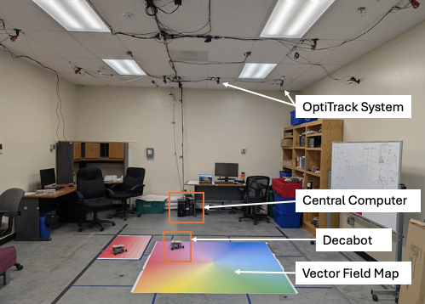
FIGURE 1: TESTBED FOR VECTOR FIELD ADAPTIVE NAVIGATION
2.2 Adaptive Navigation Control Architecture
The controller architecture used for this study has been adopted from previous cluster space control studies. The navigation of the multirobot system can be divided into 3 main parts: a layer with individual robot controllers for control over each robot, a layer with a cluster space controller for formation control, and an adaptive navigation layer for executing the control primitives. An overview of this architecture can be seen in figure 1. This architecture has been successfully demonstrated in a variety of multirobot adaptive navigation studies in 2D and in 3D scalar environment[18-21].
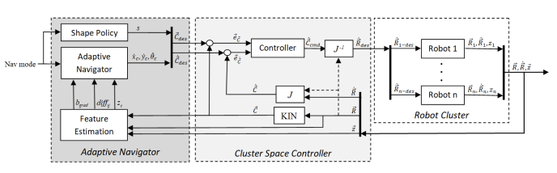
FIGURE 2: MULTILAYERED CONTROL ARCHITECTURE BLOCK DIAGRAM
This architecture was selected because its modular layered approach provides several key advantages for both current implementation and future work as new control strategies are being developed. The separation of control layers allows for independent development and testing of different components of the block diagram. This approach also maximizes system reusability, enabling systematic comparison of navigation strategies using standardized components in downstream layers. Additionally, the architecture enables the same control laws to be applied across different robot platforms and formations, facilitating extension to non-holonomic robots and non-planar robot formations and to systems with larger number of robots.
2.3 Robot Control Layer
The robot control layer is responsible for turning high level velocity commands into actuations on relevant hardware. The robots used for this testbed are Decabots, a fleet of omnidirectional rovers developed at Santa Clara University [19]. They are equipped with tcs34725 RGB sensors on their undercarriage, enabling them to sense the color patterns of the colored floor mat underneath and estimate the vector field being represented at that point. Each is powered by an Arduino and communicates over TCP/IP to a host computer that interprets the robots sensed value, uses the information to calculate and return robot velocity commands to each robot. Each robot has its own controller that translates these velocity commands into torques on its motors. Each robot has a maximum linear velocity of 0.3 m/s. No modifications to these robots from their original design were made for this study.
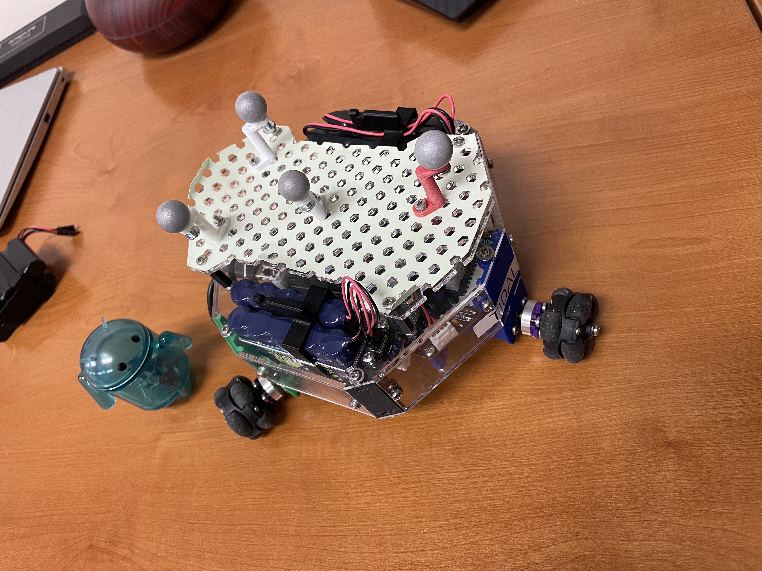
FIGURE 3: A DECABOT ROVER WITH OPTITRACK MOTION TRACKING BALLS ATTACHED

2.4 Cluster Space Controller Layer
To maintain a fixed formation while commanding all robots with velocity commands individually, a cluster space controller was used. Cluster Space control is a technique developed by Dr. Chris Kitts of Santa Clara University [22]. In this technique, all robot positions are described geometrically relative to a cluster frame via a set of kinematic equations. An example of a 3 robot cluster in a 2-dimensional plane can be seen in figure 3.
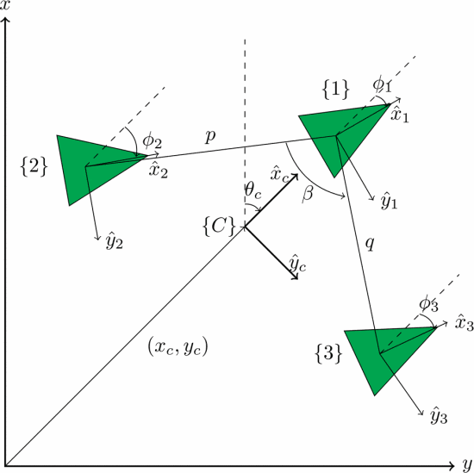
FIGURE 4: A 3-ROBOT CLUSTER WITH CLUSTER FORMATION VARIABLES
Cluster space control also provides a closed form method for converting between cluster level commands and robot level commands. This allows for the user or adaptive navigation layer to specify the behaviour commands for the entire cluster, and the individual robots are then commanded to react accordingly (see figure 4). These conversions happen on a centralized computer, after the individual robots communicate their instantaneous position and sensed information. A full description of the Kinematics, Jacobian (J) and Inverse Jacobian ( $J^{-1}$) for the cluster shown in figure 3 can be found in [2].

$$\left[\begin{matrix}{\dot{x}}_{1} \\ {\dot{y}}_{1} \\ {\dot{θ}}_{1} \\ {\dot{x}}_{2} \\ {\dot{y}}_{2} \\ {\dot{θ}}_{2} \\ {\dot{x}}_{3} \\ {\dot{y}}_{3} \\ {\dot{θ}}_{3}\end{matrix}\right] \left[\begin{matrix} \\ \\ → {J }^{ } → \\ \\ \\ ← J^{-1} ← \\ \end{matrix}\right] \left[\begin{matrix}\dot{x_{c}} \\ \dot{y_{c}} \\ {\dot{θ}}_{c} \\ \dot{p} \\ \dot{q} \\ \dot{β} \\ \dot{ϕ_{1}} \\ \dot{ϕ_{2}} \\ \dot{ϕ_{3}}\end{matrix}\right]$$
FIGURE 5: RELATIONSHIP BETWEEN CLUSTER SPACE VARIABLES AND ROBOT SPACE VARIABLES
2.5 Adaptive Navigation Layer
The adaptive navigation layer hosts the control law, the cluster shape policy, and the feature estimator. This layer determines the desired actions of the entire cluster in cluster space variables according to the control law.
The shape policy was chosen to be constant for this experiment. For this research, a 3 robot cluster with the formulation used in figure 2 was used. The cluster values, p=0.35, q = 0.35, and β= pi/3 were chosen as values for the cluster variables. This provided a tight grouping for the robots, and also ensured the shape was of an equilateral triangle. The ability to maintain this formation explicitly while maintaining full controllability and observability was the reason cluster control was chosen as the middle layer, instead of a swarm architecture or other alternative. The orientation of the cluster and of the individual robots was not specified. This was done to ensure all velocity commands were directly related to the control primitives, and not to maintaining orientation.
The feature estimator is responsible for processing data collected and transmitted by the Decabots into useful information for the control law. More information on how the feature estimator works is discussed in section 2.6.
Two different Adaptive Navigation Primitives were used to test the effectiveness of this new platform. Both primitives were previously identified and verified in simulation [2] and their limitations discussed. It is important to note that these primitives only rely on instantaneous information, and as such allow for purely reactive approach to adaptive navigation control.
The first primitive is the vector sum technique. In this technique, the vectors sensed by each robot are summed together. The direction of the resultant vector is then normalized and used to specify ${\dot{x}}_{c}$ and ${\dot{y}}_{c}$ for the cluster.
In the Vector to Scalar technique, only the magnitude information from the vector readings is used, effectively converting the vector field navigation problem into a scalar field problem. This allows for scalar field gradient ascent primitives to be used. For example, in the max seeking primitive, differences in magnitude of the vector readings from the individual robots are used to calculate the normal angle to the plane formed by these measurements, which is then projected to determine the direction of steepest change. Equations 2 through 6 describe this max seeking primitive, showing how the x and y coordinates of each robot and the magnitude of their vector readings (z) are used to specify ${\dot{x}}_{c}$ and ${\dot{y}}_{c}$ for the cluster. A minimum seeking behaviour follows the same equations, except moving in the negative ${\dot{x}}_{c}$ and ${\dot{y}}_{c}$ directions.
$$\begin{aligned}{\vec{R}}_{12}=\left({x_{2}-x_{1} \atop \begin{aligned}y_{2}-y_{1} \\ z_{2}-z_{1}\end{aligned}}\right) \#\left(1\right)\end{aligned}$$
$$\begin{aligned}{\vec{R}}_{13}=\left({x_{3}-x_{1} \atop \begin{aligned}y_{3}-y_{1} \\ z_{3}-z_{1}\end{aligned}}\right) \#\left(2\right)\end{aligned}$$
$$\begin{aligned}\vec{N}={-\vec{R}}_{13}× {\vec{R}}_{12} \#\left(3\right)\end{aligned}$$
$$\begin{aligned}b_{grad}=ATAN2\left(N_{y} , N_{x}\right)+ \frac{π}{2} \#\left(4\right) \\ {\dot{x}}_{c}=cos⁡( b_{grad} )\#\left(5\right) \\ {\dot{y}}_{c}=cos⁡( b_{grad} )\#\left(6\right)\end{aligned}$$

2.6 Modelling Vector Fields in Colorspace
Previous attempts to use RGB colors to represent an orthogonal set of vectors showed limited success as only as small portion of the spectrum was usable when portions of high interference were eliminated [18] . To allow for more variance in colors, an HSV colorspace was used to model vector space. Hue, which is circular in nature, was a natural choice for representing the direction of the vector. Saturation, ranging from 0 to 1, was used to represent the possible range og magnitudes. Saturation was chosen for representing magnitudes as early tests found that the value channel was very sensitive to differences in ink levels from the printer, ambient lighting, and other effects such as shadows.
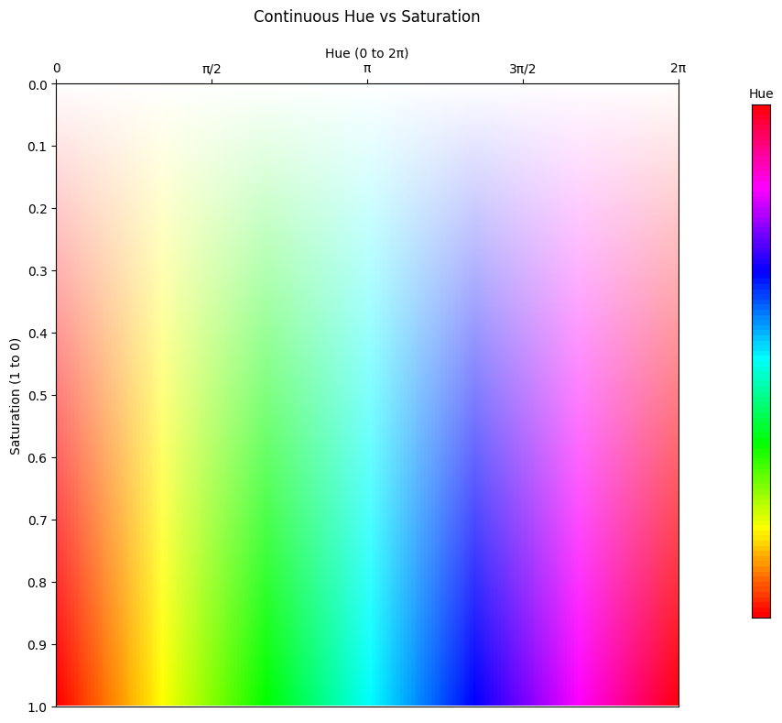
FIGURE 6: A PLOT OF SATURATION VS HUE TO REPRESENT VECTOR SPACE
2.7 Feature Estimation and Sensor Calibration
Since the robots’ sensors collected RGB samples and not HSV, the channel interference issue discussed earlier persisted when converting RGB readings to HSV. Attempts at using a linear tuning, second order polynomial, log, and a linear piecewise tuning were unsuccessful. An attempt at using a restricted portion of the color spectrum that didn’t have interference resulted in a such a limited portion of the spectrum being usable that it was impractical for real world adoption. These limitation motivated using a nonlinear tuning technique. A Supervised Learning Approach using shallow neural networks was used to tune each robot’s sensor was developed. The process described below was repeated for each robot.
A calibration pallet was created with varying hue (0-2π) and saturation (0-1) values at 24 equal intervals in each dimension. RGB and K measurements were recorded for each square, along with their target Hue and Saturation readings. The dataset was augmented by introducing ±1% noise to RGB readings, effectively tripling the dataset size to improve robustness. Values were clipped between 0 and 1 to ensure data validity.
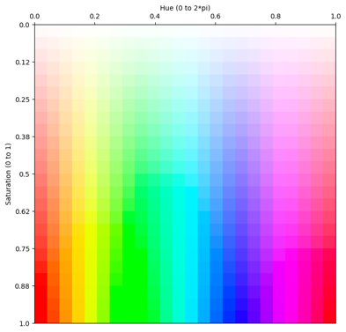
FIGURE 7: DISCRETE SATURATION VS HUE PLOT USED FOR TRAINING VECTOR ESTIMATING MODELS
The raw RGBK values were normalized to the range [0,1]. These normalized values were then converted to HSV space using standard MATLAB libariries, and this data was appended to original data. This was done as feature engineering, and it is believed to be a useful addition to help model convergence. Data points with values less than 0.2 were removed from the data set, as including them in training decreased model performance. To handle the circular nature of hue values, the hue target was decomposed into sine and cosine components, creating a two target configuration. Saturation was handled with direct mapping. This resulted in a 7 dimensional input space (R,G,B,K,H,S,V). All inputs and Target values were normalized to [-1,1] range for training.
Two separate neural networks were implemented using MATLAB's Deep Learning Toolbox: One to predict Hue and the other to predict saturation. The saturation network has a single neuron output. The hue network had a two neuron output, representing the decomposed sine and cosine component of the direction.
To determine the appropriate size of the hidden layers, multiple models were created with 2 hidden layers, ranging from 2,2 to 8,8 for both hue and saturation. This resulted in multiple models being trained for each robot (98 each, 48 for hue, and 48 for saturation).
For both networks, Tanh activation functions were used for non-linearity. The Levenberg-Marquardt optimizer was employed with default learning rate settings. Early stopping was implemented using MATLAB's default configurations to prevent overfitting. The data was split into training (70%), validation (15%), and test (15%) sets. The default convergence criterium was used.
Model outputs were denormalized from [-1,1] to [0,1], with values clipped to ensure valid ranges. The two-neuron hue output was recombined to produce a single hue value in the range [0,2π].
Validation testing was performed to ensure that the models aren’t overfitting and generalize well to unseen data. A separate test pallet with previously unseen values, with saturation levels ranging from 0.05 to 0.95 in 0.1 intervals, and hue divided into 10 equal intervals from 0 to 2π. The same printer was used throughout to maintain consistency in the color reproduction from training plot to verification plot. The verification plots were measured then preprocessed into a 7-dimensional form for model inference.
For each robot, the model with the best R² performance on the verification test plot was selected. The architecture of model, as well as its performance is listed in Table 1 below.
While the R² metric provided initial performance insights, it revealed limitations in capturing the nuanced nature of hue estimation. The circular nature of hue means that traditional linear error metrics can cause errors to be overstated. For instance, a prediction of 0.01 for a target near 0.99 represents a minimal actual difference of approximately 0.02 radians, despite appearing as a large error in linear space of 0.98. A more specialized evaluation techniques that account for the circular nature of angular measurements. [23]

TABLE 1: ARCHITECTURE AND PERFORMANCE OF EACH MODEL SELECTED FOR INFERENCE
Model | Hidden Layer Dimensions | Training plot performance | hue testing plot performance
Robot1 Hue | [6,4] | 0.9445 | 0.9467
Robot1 Sat | [6,5] | 0.9536 | 0.9555
Robot2 Hue | [4,3] | 0.9393 | 0.9976
Robot2 Sat | [7,5] | 0.9618 | 0.9493
Robot3 Hue | [7,7] | 0.9053 | 0.9921
Robot3 Sat | [7,4] | 0.9349 | 0.9007

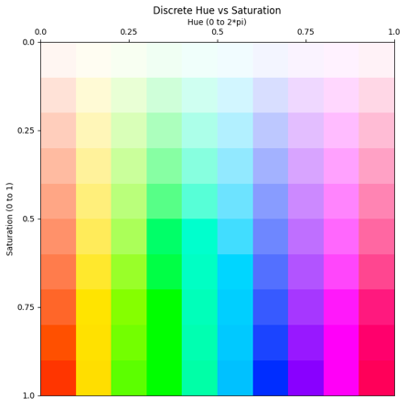
FIGURE 8: DISCRETE VERSIONS OF THE SATURATION VS HUE PLOT USED FOR TESTING VECTOR ESTIMATING MODELS

2.8 Cross-Robot Calibration Generalization
In order to address the future scaling up of the testbed to larger numbers of Decabots, an investigation was conducted into whether a single calibration model could be used across multiple robots. Since all Decabots use identical TCS34725 RGB sensors, it was hypothesized that a single model could accommodate the manufacturing variations between units.
The calibration data from the first three robots was aggregated into a single dataset, and a model was trained using this combined dataset, as well as a 1x data augmentation (adding 1% noise). All other processing steps remained identical to those described in section 2.7.
A fourth robot, not included in the training process, was then used to collect RGBK data from the calibration pallet used before. This dataset from robot 4 was used to validate the model.
The resulting networksuccessfully predicted hue and saturation from robot 4's R,G,B,K readings with a circular r² of 0.99 and RMSE of 0.02 for hue, and an r² of 0.90 and RMSE of 0.08 for saturation.
This approach eliminates the need for individual calibration of each new robot, reducing setup time from approximately 2 hours per robot to under 10 minutes. More importantly, it means that a single "catch-all" model can be loaded onto all robots in the fleet, simplifying deployment and configuration. With the Decabot fleet consisting of over 10 robots, this generalization capability is crucial for efficient scaling. While this generalized model wasn't used in the navigation experiments below, it represents a significant practical advancement for scaling to larger robot teams without sacrificing measurement accuracy. This cross-robot validation technique could potentially be used with different robots and different sensors in the future.

- RESULTS AND DISCUSSION

3.1 Inference to Predict Hue and Saturation
All models used to estimate hue had an accuracy greater than 0.9, and all models used to estimate saturation had an accuracy. Figures 9 through 12 show the model performance of robot 1 with test and validation data.
Similar results were seen with the other models trained for the other robots, all having R² values over 0.90 on the verification plot.

FIGURE 9: ACTUAL HUE VS PREDICTED HUE ON CALIBRATION DATA ON ROBOT1

FIGURE 10: ACTUAL SATURATION VS PREDICTED SATURATION ON CALIBRATION DATA ON ROBOT1

FIGURE 11: ACTUAL SATURATION VS PREDICTED SATURATION ON VERIFICATION DATA
FIGURE 12: ACTUAL SATURATION VS PREDICTED SATURATION ON VERIFICATION DATA

3.2 Vector Magnitude to Robot Velocity Tuning
To test that the robots were able to accurately adjust their velocities based on the magnitudes of the vectors, lanes of a single hue at different saturation levels were printed (figure 13). The robot was placed on each of the different saturation lanes and was commanded to follow the direction based on hue, and to use the magnitude indicated by saturation to scale its velocity.
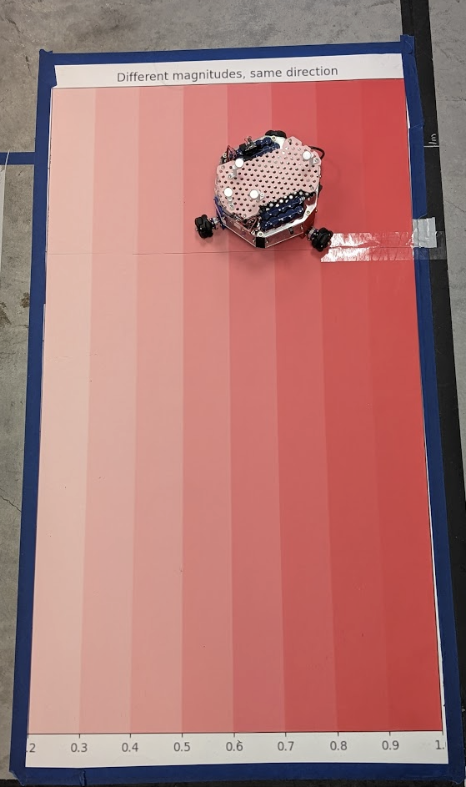
FIGURE 13: ACTUAL SATURATION VS PREDICTED SATURATION ON VERIFICATION DATA
The robot’s position was tracked over a 3 second period for each lane, and the velocity was calculated as the difference in location at time step, divided by the length of the time step (0.1s) (figure 14).
FIGURE 14: VELOCITY OF ROBOTS AS A FUNCTION OF TIME
The average velocity for each saturation was computed and plotted against saturation (figure 15). The velocities scaled linearly with saturation. Saturations below 0.3 were not considered, as the resulting velocity commands were not strong enough to overcome stiction of the robots. The robots also did achieve their known max velocities, probably due to inaccuracies in predicting a saturation of 1.
FIGURE 15: AVERAGE VELOCITY OF ROBOTS WHEN SENSING DIFFERENT SATURATION LEVELS

3.3 Testbed Results
Previous investigation into vector field navigation demonstrated success in using the vector to scalar technique to create a vector magnitude map, and the min seeking primitive in simulation. This study also successfully demonstrated the vector sum primitive to follow a vector flow field in simulation. This made them ideal primitives to test on our testbed.
The first vector field studied was that of a fixed vortex. It was modelled using equations 7 through 10 below:
$$\begin{aligned} r = {\left({\left(x - center_{x}\right)}^{2} + {\left(y - center_{y}\right)}^{2}\right)}^{\frac{1}{2}} \#\left(7\right) \\ θ = atan2(y - center_y, x - center_x) \#\left(8\right) \\ u = r * sin⁡(θ) \#\left(9\right) \\ v = -r * cos⁡(θ) \#\left(10\right)\end{aligned}$$

Once all the vectors have been created at every point in the plot, they were scaled to the range of 0.3 to 1. Values less than 0.2 were not used in training, and values less than 0.3 have problems with stiction.
Figure 16 below shows the resulting quiver plot, and its representative HSV plot.
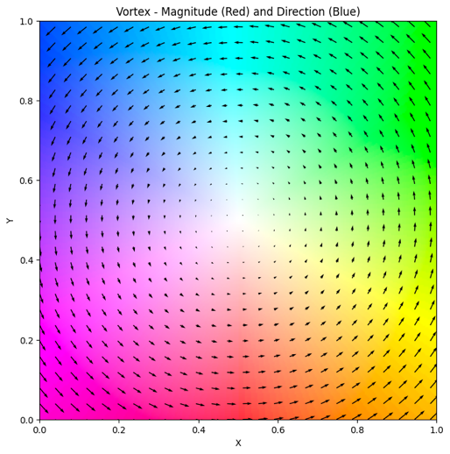
FIGURE 16: AVERAGE VELOCITY OF ROBOTS WHEN SENSING DIFFERENT SATURATION LEVELS

A 3 robot cluster following this pattern would be expected to form a perfect circle. Instead, there seems to be a small outward spiraling of the robot cluster, probably due to momentum as seen in figure 17. This is expected as the robot only moves in is perceived direction, and time increments mean it is always moving tangent to the circle. This behaviour could possibly be mitigated with a more advanced primitive.
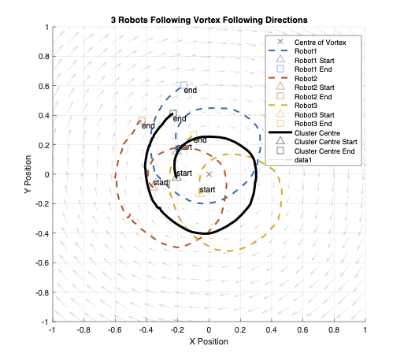
FIGURE 17: AVERAGE VELOCITY OF ROBOTS WHEN SENSING DIFFERENT SATURATION LEVELS

However, figure 18 shows the cluster values, p=0.35, q = 0.35, and β= pi/3 being maintained well.
FIGURE 18: AVERAGE VELOCITY OF ROBOTS WHEN SENSING DIFFERENT SATURATION LEVELS
When converting this fixed vortex vector field to a magnitude plot and using a min seeking primitive, the robots are expected to follow a straight line to the centre. Figure 18 shows this behaviour. The trajectory isn’t a perfect line, as there may be noise in the printing, small fluctuations in robot behaviour, and some known variance in the way that saturations are used to estimate magnitudes.
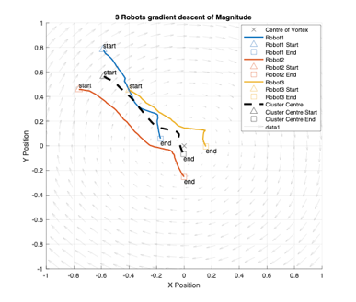
FIGURE 19: AVERAGE VELOCITY OF ROBOTS WHEN SENSING DIFFERENT SATURATION LEVELS
We see the cluster values, p=0.35, q = 0.35, and β= pi/3 being maintained here as well on figure 20. The final distance from the resting point is less than 0.1m from true centre. The centre is within the triangle formed by the three robots. More research is needed to specify how precisely the cluster can find the centre on this test bed.

FIGURE 20: AVERAGE VELOCITY OF ROBOTS WHEN SENSING DIFFERENT SATURATION LEVELS
The other vector field studied was that of a sinking vortex. The equations below describe how the vector field is modeled. A small value of $1e^{-6}$was added to denominator to avoid errors when attempting to divide by 0 when r=0. Once again, all vectors in the plot are scaled to the range of 0.3 to 1 after They are computed using equations 11-16 below. The resulting vector field is shown in figure 19.
$$\begin{aligned} r = {\left({\left(x - center_{x}\right)}^{2} + {\left(y - center_{y}\right)}^{2}\right)}^{\frac{1}{2}} \#\left(11\right) \\ θ = atan2(y - center_y, x - center_x) \#\left(12\right) \\ u = r * sin⁡(θ) \#\left(13\right) \\ v = -r * cos⁡(θ) \#\left(14\right) \\ u = u+\frac{{0.1*\left(x - center_{x}\right)}^{ }}{r^{2} +1e^{-6}} \#\left(15\right) \\ v = v+\frac{{0.1*\left(y - center_{y}\right)}^{ }}{r^{2} +1e^{-6}} \#\left(16\right)\end{aligned}$$

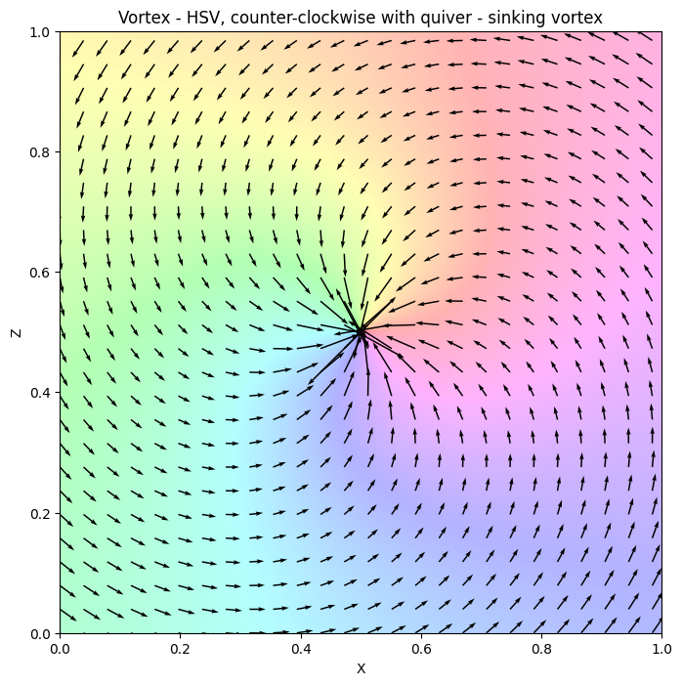
FIGURE 21: AVERAGE VELOCITY OF ROBOTS WHEN SENSING DIFFERENT SATURATION LEVELS
Figure 20 shows the robots following a smooth path as they spiral inwards towards the centre, just as predicted in simulation. The smoothness can be attributed to very high R² value when reconstructing hue. Also, this centre is a stable focus, which helps the smooth motion. In this example, we see the cluster variables being maintained, while the steady state error from the centre is less than 0.5
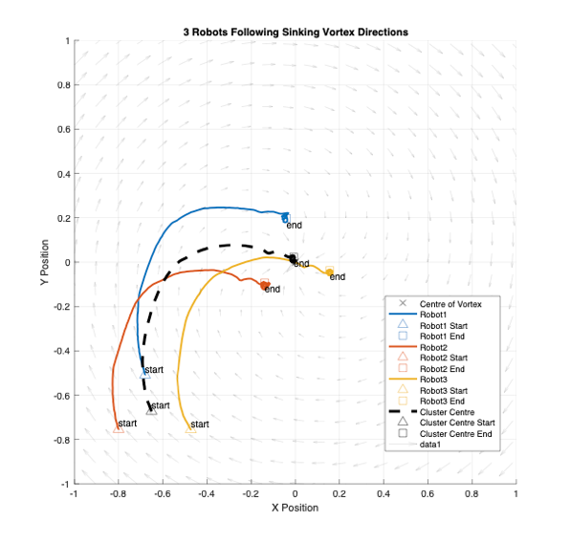
FIGURE 22: AVERAGE VELOCITY OF ROBOTS WHEN SENSING DIFFERENT SATURATION LEVELS
FIGURE 23: AVERAGE VELOCITY OF ROBOTS WHEN SENSING DIFFERENT SATURATION LEVELS

When converting to a magnitude only plot and using the max seeking primitive, the robots do not have a spiraling inward motion as seen in figure 20, but travel a direct path to the centre, instead as seen in figure 21. This behaviour seen in figure 20 and 21 was predicted in simulation [2].
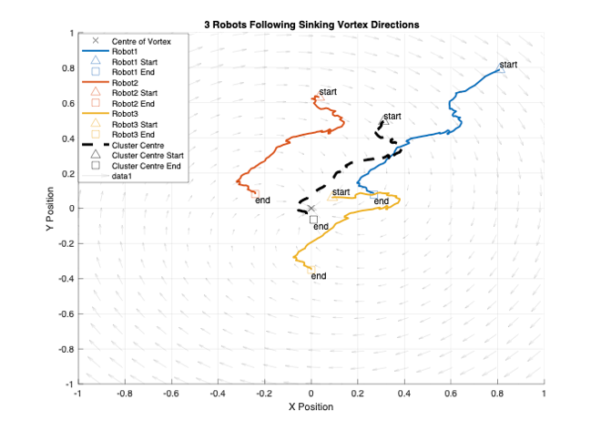
FIGURE 24: AVERAGE VELOCITY OF ROBOTS WHEN SENSING DIFFERENT SATURATION LEVELS
On this run, the cluster variables converge to their desired positions, and the final resting point of the cluster is less than 0.1m away from the true value.
FIGURE 25: AVERAGE VELOCITY OF ROBOTS WHEN SENSING DIFFERENT SATURATION LEVELS
3.4 System Limitations
While this testbed demonstrates a significant improvement over previous testbeds, some limitations persist. The system is fundamentally constrained to two-dimensional vector fields, and a method for extending to 3 dimensions using HSV color space is not possible due to extreme sensitivity in the value component. Any extension to 3 dimensions would require using a different sensor to interpret some other metric and combine into a vector.
The testbed area is also limited to a maximum of a 3m by 6m work area, and a minimum operational area of 1m x 1m to allow robots room to operate without collision.
The Decabots themselves are limited by their battery life to about an hour run time. They have a maximum velocity of 0.3ms and a minimum velocity of 0.08 m/s to overcome stiction. The acceleration capabilities of the rovers are not well studied.
Finally, using the Decabots wheels on the colormaps degrade the paper and the color on the paper with time, necessitating the need to print new colormaps after a few dozen runs, which is quite costly.
3.5 Future Work and Potential Applications
Further improvements to the test bed include performing an error analysis on position accuracy, formation maintenance, and response time to properly quantify the system's capabilities.
The testbed can be used to validate simulations of new control primitives that are currently in development to find features of interest in vector fields, such as navigation to stagnation points and maintaining orbit at a fixed distance. The approaches being developed use a more advanced mathematical approaches could be investigated, including Jacobian-based analysis with eigenvalue decomposition, and calculations of curl and divergence to understand the topological features of the vector fields. This could extend to working with singularities in vector fields, singularities with certain robot formations, and incorporating complex trajectories such as homoclinic orbits [24-25].
The system's ability to accurately reproduce both direction and magnitude of vectors enables the study and testing of real-world dynamics of multirobot systems. Studying the dynamics of a cluster as a whole has not been studied in depth, and this test bed allows for development of this area of research. Digital twins of the decabots can be made to further enhance the sim2real experience. [26]
The platform could also serve as an experimental environment for multirobot reinforcement learning algorithms, and for testing artificial vector field control methodologies.
While the current implementation uses a cluster space control approach, future work could explore replacing this middle layer with swarm-based controllers. Additionally, the method could scale to larger numbers of robots, though this would require developing new kinematics and Jacobian transformations to maintain system performance.

- CONCLUSION

This project was successful in overcoming the limitations of previous vector field testbeds. This testbed can accurately represent direction and magnitude with an R2 accuracy of over 0.9 in hue and direction. It demonstrated multirobot capabilities and had motion capture mechanisms to verify the performance in a quantifiable manner. It overcame the channel coupling issue using a supervised learning approach. It demonstrated that the testbed could be used for experimental verification of results from previous vector field studies that were only performed in simulation. It also opens the door to testing new control strategies for other vector field environments in a real-world testbed.
ACKNOWLEDGEMENTS
Special thanks to Scot Tomer for taking time to review the original Decabots Test Bed, and to Jiayi Wang who helped facilitate the large-format printing in house. Special thanks also goes out to Dr. Sharma and Dr. Neumann for helping to proof read and edit this paper.

REFERENCES
[1] C. A. Kitts and M. Egerstedt, “Design, control, and applications of real world multirobot systems [from the Guest Editors],” IEEE Robot. Autom. Mag., vol. 15, no. 1, p. 8, Mar. 2008.
[2] Cooper, Ryan, et al. "Initial Study of Multirobot Adaptive Navigation for Exploring Environmental Vector Fields." 2019 IEEE Aerospace Conference. IEEE, 2019.
[3] Gradient-Based Cluster Space Navigation for Autonomous Surface Vessels Thomas Adamek, Member, IEEE, Christopher A. Kitts, Senior Member, IEEE, and Ignacio Mas, Member, IEEE
[4] S. T. Hart and C. A. Kitts, "Unifying Control Architecture for Reactive Particle Swarms," in IEEE/ASME Transactions on Mechatronics, vol. 28, no. 2, pp. 873-883, April 2023, doi: 10.1109/TMECH.2022.3211155.
[5] C. A. Kitts, R. T. McDonald, and M. A. Neumann, “Adaptive navigation control primitives for multirobot clusters: Extrema finding, contour following, ridge/trench following, and saddle point station keeping,” IEEE Access, vol. 6, pp. 17 625–17 642, 2018.
[6] McDonald, Robert T., et al. "Navigation of scalar fronts with multirobot clusters in simulation and experiment." IEEE Systems Journal 14.3 (2020): 3755-3766.
[7] Wang, J., Guo, Y., Fahad, M., and Bingham, B., 2019, “Dynamic Plume Tracking by Cooperative Robots,” IEEE/ASME Transactions on Mechatronics, early access.
[8] Hu, Bin-Bin, et al. "Spontaneous-Ordering Platoon Control for Multirobot Path Navigation Using Guiding Vector Fields." IEEE Transactions on Robotics (2023).
[9] Nelson, Derek R., et al. "Vector field path following for miniature air vehicles." IEEE Transactions on Robotics 23.3 (2007): 519-529.
[10ve] Liddy, Tommie, et al. "Obstacle avoidance using complex vector fields." Proc. of the 2008 Australasian Conference on Robotics and Automation, Canberra, Australia. 2008. – Single Robot with artificial vector field.
[11] Matveev, Alexey, et al. "Gradient-free tracking of unsteady environmental level sets in dynamic environments by a nonholonomic robot." IFAC-PapersOnLine 53.2 (2020): 9256-9261.
[12] Matveev, Alexey, et al. "Non-Gradient Based Tracking of Environmental Field Isolines in a Changing Medium by Dubins-Vehicle Type Robots." IEEE Transactions on Automatic Control (2023).
[13] Thangavelautham, Jekan, and Yinan Xu. "Co-Evolution of Multi-Robot Controllers and Task Cues for Off-World Open Pit Mining." arXiv preprint arXiv:2009.09149 (2020).
[14] Kalita, Himangshu, et al. "Guidance, navigation and control of multirobot systems in cooperative cliff climbing." arXiv preprint arXiv:1701.07553 (2017)
[15] Michael, Nathan, Jonathan Fink, and Vijay Kumar. "Experimental testbed for large multirobot teams." IEEE robotics & automation magazine 15.1 (2008): 53-61.
[16] Rajabhandharaks, Danop, et al. "Indoor Testbed for Vector Field Multirobot Adaptive Navigation: Feasibility Study." International Design Engineering Technical Conferences and Computers and Information in Engineering Conference. Vol. 59292. American Society of Mechanical Engineers, 2019.
[17] S. Tomer et al., "A low-cost indoor testbed for multirobot adaptive navigation research," 2018 IEEE Aerospace Conference, Big Sky, MT, USA, 2018, pp. 1-12, doi: 10.1109/AERO.2018.8396787.
[18] I. Mas, S. Li, J. Acain, and C. A. Kitts, “Entrapment/escorting and patrolling missions in multi-robot cluster space control,” in Proc. IEEE/RSJ Int. Conf. Intell. Robots Syst., St. Louis, MO, USA, Oct. 2009, pp. 5855– 5861.
[19] M. Woolsey, C. A. Kitts and M. A. Neumann, "Gradient-based Adaptive Navigation of Multiple Diving Autonomous Surface Vehicles," OCEANS 2022, Hampton Roads, Hampton Roads, VA, USA, 2022, pp. 1-8, doi: 10.1109/OCEANS47191.2022.9977006.
[20] Lee, Robert K., et al. "3-d adaptive navigation: Multirobot formation control for seeking and tracking of a moving source." 2020 IEEE Aerospace Conference. IEEE, 2020.
[21] R. K. Lee, C. A. Kitts, M. A. Neumann and R. T. Mcdonald, "Multiple UAV Adaptive Navigation for Three-Dimensional Scalar Fields," in IEEE Access, vol. 9, pp. 122626-122654, 2021, doi: 10.1109/ACCESS.2021.3107854.
[22] C. A. Kitts and I. Mas, "Cluster Space Specification and Control of Mobile Multirobot Systems," in IEEE/ASME Transactions on Mechatronics, vol. 14, no. 2, pp. 207-218, April 2009, doi: 10.1109/TMECH.2009.2013943.
[23] Jammalamadaka, S. Rao, and Ambar Sengupta. Topics in circular statistics. Vol. 5. world scientific, 2001.
[24] Hart, Shae T., Jake Kamenetsky, and Christopher A. Kitts. "Dynamic Elliptical Shaping Control for Swarm Robots." IEEE Access 11 (2023): 17454-17470.
[25] Yao, Weijia, et al. "Singularity-free guiding vector field for robot navigation." IEEE Transactions on Robotics 37.4 (2021): 1206-1221.
[26] Mañas-Álvarez, Francisco-José, et al. "Robotic park: Multi-agent platform for teaching control and robotics." IEEE Access 11 (2023): 34899-34911.

